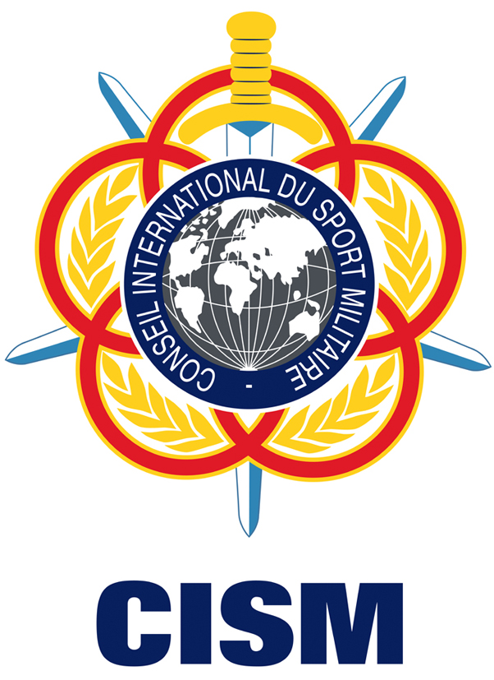 | Solidarity Travel Plan to the  3rd CISM World Winter Games  Sochi 2017 | 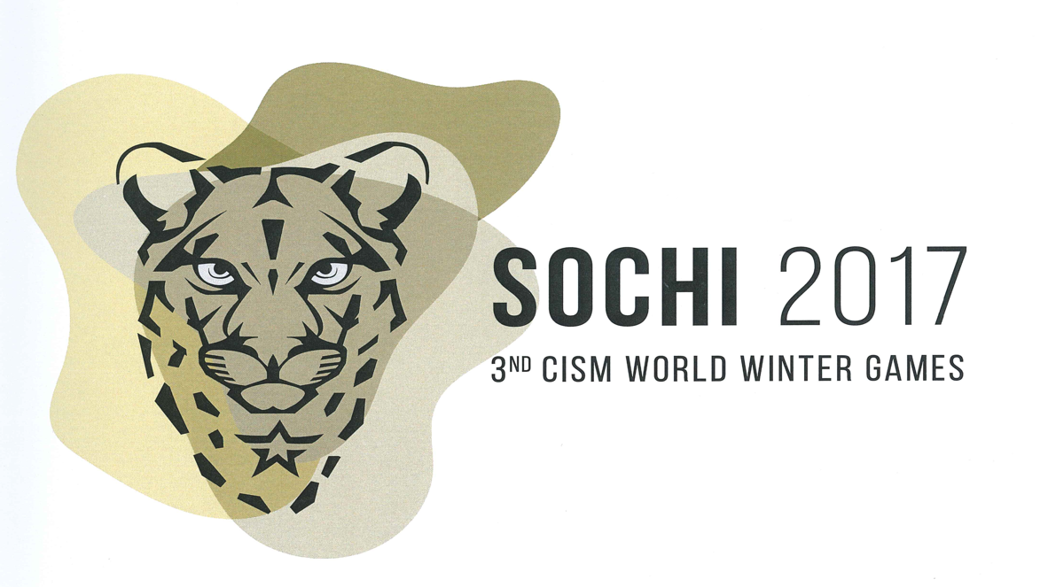
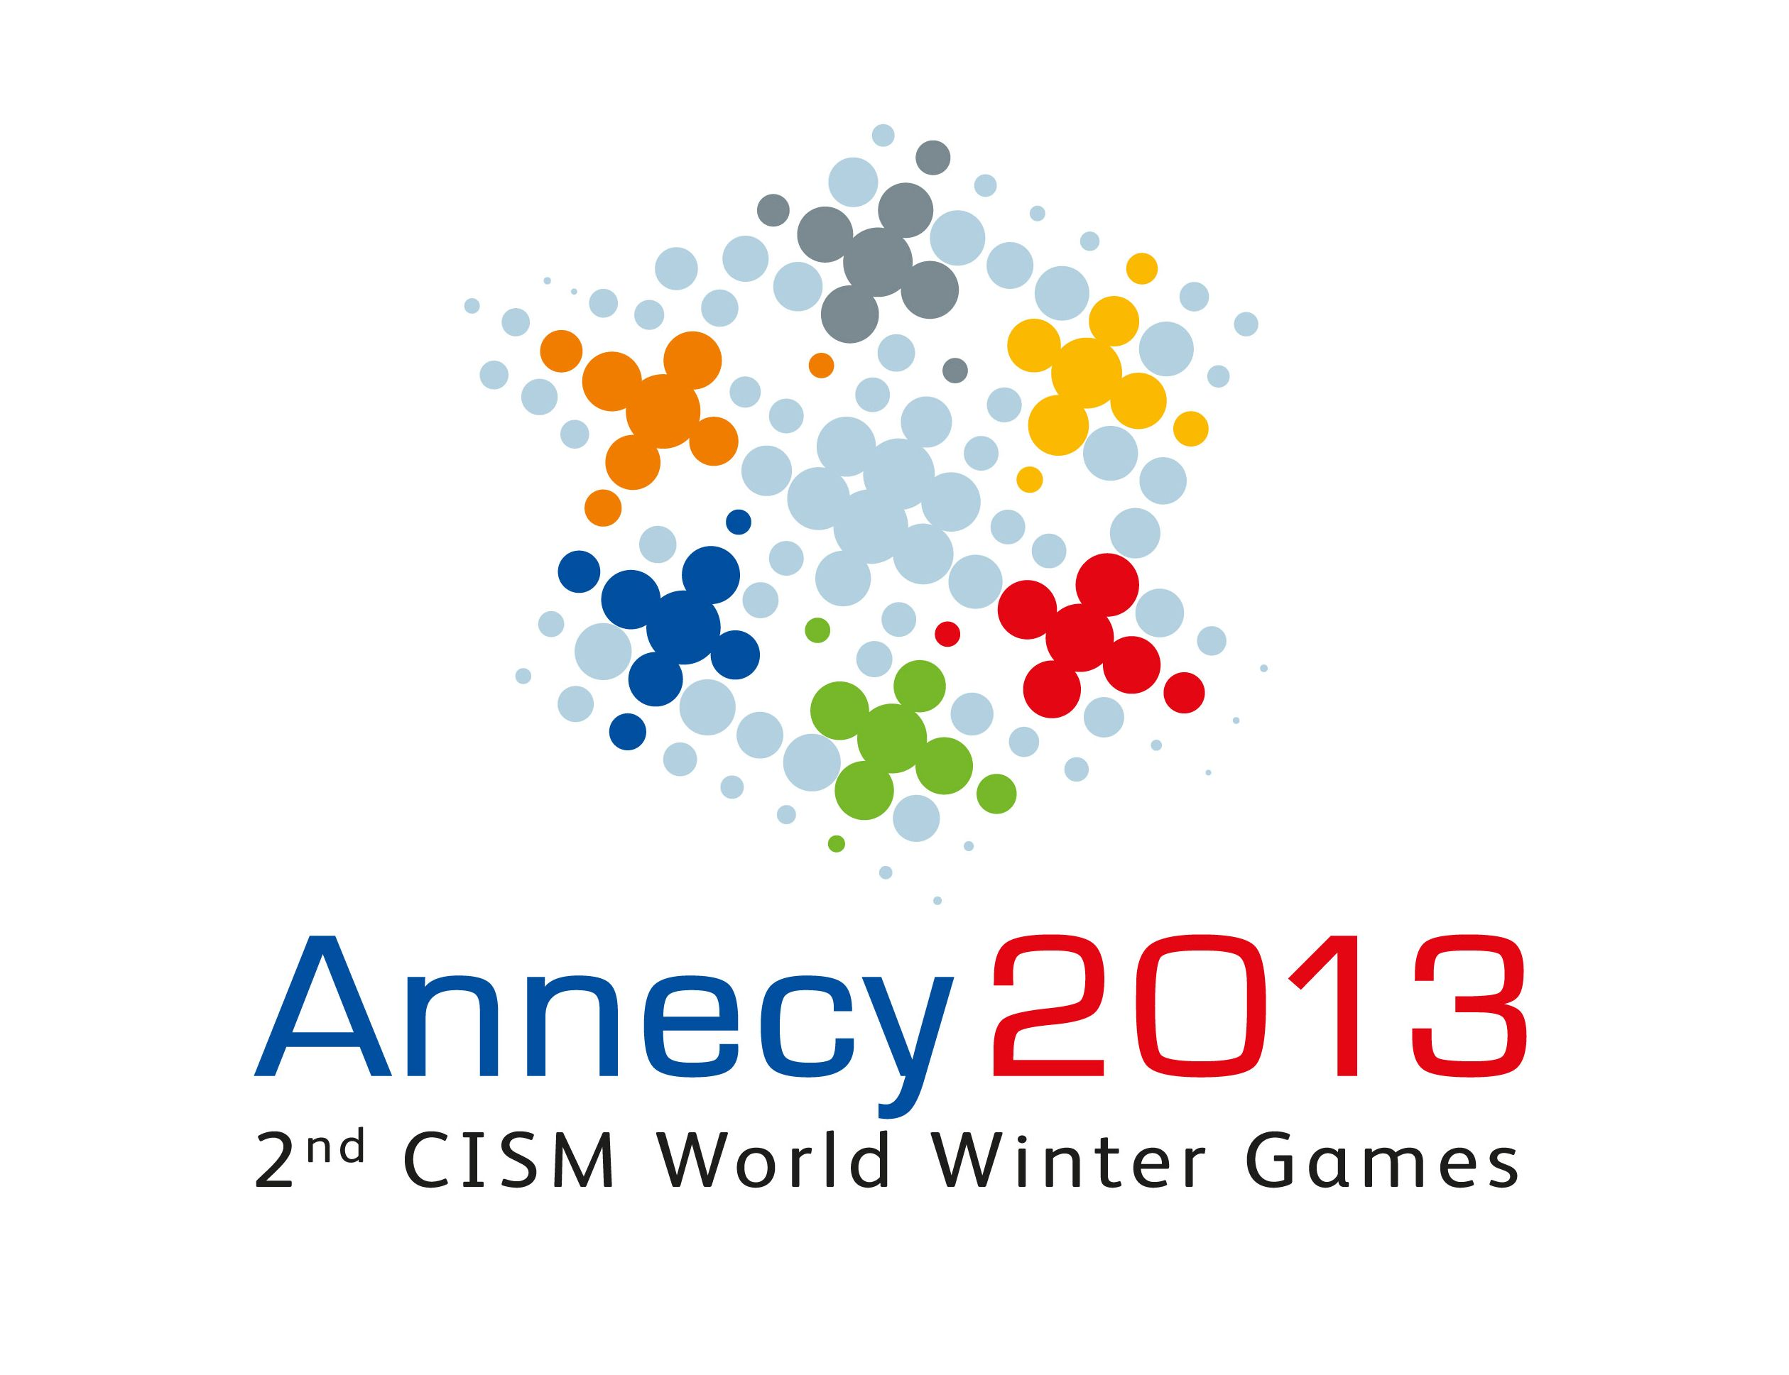
1. Introduction

Following successful experience during the 2nd CISM World Winter Games and 6th CISM Military World Games, CISM is striving to organize another solidarity action to the 3rd CISM World Winter Games, to be held in Sochi – Russia, from 23 to 27 February 2017.

This aims at supporting our member countries in order to give them the opportunity to participate in this great CISM winter event.

The CISM World Winter Games is one of the best opportunities to develop the CISM motto Friendship through Sport. A substantial number of military sportsmen and women have the opportunity to represent their countries in the sports fields sharing their personal experiences with other cultures and societies.

2. Objective

To help CISM delegations attending the 3rd CISM World Winter Games with top level athletes who do not have financial conditions to attend the event.

3. Criteria of Inclusion

  - Be an active CISM nation;
  - Attend the invitation file procedures;
  - Be classified in Fee Category A, B or C according to 2016 Annual Membership Fee.

  - Maximum of 4 persons, 1 Coach and 3 athletes.

  - Mission with more than four (4) contingent, might have bi-literal discussion with CISM solidarity project officer base on availability of funds.

4. Procedures

  - This project will support only travel expenses by train, plane or bus considering the most advantage to CISM and the Delegation involved in the plan.
  - All other expenses related to the travel (local transportation to/from the airport, food, etc), must be covered by the Delegation who will be supported.
  - All formal procedures as Visa, minimum of money and permissions to go abroad, to land in some transitory countries and also to have the permission to enter in Russia must be carried out by the Chief of Delegation from the military supported.
  - The athlete must be nominated by his/her own Delegation to CISM and follow the conditions below:
    - Took part in at least one international event of his/her discipline in the last two years (2014/2016).
    - Be among the top three athletes of his/her Armed forces between 2014 - 2016, proved by the International or National Federation.
  - The Chief of Delegation must fill in and sign the final travel plan agreement form (see Annex 1) and attach the proof document from the National Olympic Committee, International or National Federation of the discipline required for the athlete appointed.
  - If some nation would have more than three (3) athlete, the Chief of delegation should send an official letter to CISM Secretary General who will appreciate each case, considering the arguments and the financial conditions.
  - The tickets provided will be in economical class from the country supported to Russia. It might there be another possibility, in which the final destination to Sochi can be provided by military aircraft from a CISM member nation who would like to attend the project as a stakeholder and join effort with CISM in order to facilitate the transport. In this case CISM will pay the tickets only from the supported country to those member nations that support this plan with military transportation.
  - Due to administrative reasons, once the ticket is bought, it definitely won’t be possible to change the name of the persons applied. That’s why it is really important to be precise in filling the data in the form attached.
  - CISM Solidarity and Technical Assistance Project Officer will check whereas the athlete is qualified for this travel plan based on information and data available.
  - CISM General Secretariat will inform the decision to the country that will have more 10 days to send to CISM General Secretariat all confirmations related to Visa and formal procedures to enter Russia, considering also other countries where the militaries probably will make the transfers. This means that all the procedures to get the Visa starts as soon as possible;
  - The tickets would be issued from the capital of the country to Lyon Sochi International Airport. The transports costs from the city of the person to the capital of his country must be supported by his/her Delegation. Transportation from Sochi airport to venue will be provided by the 3rd CISM World Winter Games Organizing Committee (WINOC), according to the Invitation File;
  - One version of the electronic ticket will be sent to the Chief of Delegation, who must confirm immediately after receiving it.

  - Cancelations should be avoided, ticket not used the Chief of Delegation have to refund CISM HQ.
  - At any time CISM can deny the support considering the financial resources available.

5. Deadline

The form (Annex1) must be filled, signed by the CoD and send to CISM GS before 30 September 2016.

6. Arrival and Departure Day

According the Invitation File of the 3rd CISM World Winter Games (This file can be found on the CISM website.

7. Stakeholders

- International Military Sports Council - General Secretariat - CISM GS;
- International Olympic Committee – IOC;
- 3rd CISM World Winter Games Organizing Committee - WINOC;

8. CISM Contacts

Conseil International du Sport Militaire
Rue Jacques Jordaens, 26
1000- Brussels
Belgium
Website: www.cism-milsport.org

CISM Solidarity & Development Project Manager - Col Abdulraheem Bello
Tel.: +32 02 650 02 87
Fax: +32 02 647 53 87
E-mail: abdulraheem.bello@cism-milsport.com

CISM Solidarity & Development - Cdr Marcos Lucio
E-mail: marcos.lucio@cism-milsport.com

Tel.: +32 02 650 02 87

Annex 1


Solidarity Travel Plan to the
3rd CISM World Winter Games

To be returned before 30th of September 2016

CISM General Secretariat
Rue Jacques Jordaens, 26, B-1000, Brussels - Belgium
abdulraheem.bello@cism-milsport.com
marcos.lucio@cism-milsport.com

Phone: +32 (0)2 650 02 84
Fax: +32 (0)2 647 53 87

FINAL TRAVEL PLAN AGREEMENT

COUNTRY:

City of departure:
Date of departure:

COACH (mandatory)

Last name: First name:
(As issued in the passport) (As issued in the passport)
Rank:
Passport number:
Date of issue:
Birth date:
Phone:
Fax

ATHLETES

1st athlete
Last name: First name:
(As issued in the passport) (As issued in the passport)
Rank:
Passport number:
Date of issue:
Birth date:
Sport:
Discipline:
Best performance (result):
Year:
Event:
International experience:

Last competitive performance (result):
Year:
Event:

*2nd athlete
Last name: First name:
(As issued in the passport) (As issued in the passport)
Rank:
Passport number:
Date of issue:
Birth date:
Sport:
Discipline:
Best performance (result):
Year:
Event:
International experience:

*3rd athlete
Last name: First name:
(As issued in the passport) (As issued in the passport)
Rank:
Passport number:
Date of issue:
Birth date:
Sport:
Discipline:
Best performance (result):
Year:
Event:
International experience:

Last competitive performance (result):
Year:
Event:

Date: Signature of Chief of Delegation: _ _ _ _ _ _ _

Rank/Name: _ _ _ _ _ _ _ _ _ _ _ _ _ _ _ _ _ _
Don’t forget to attach all necessary documents in order to officially attest your athletes’ performances and a copy of your passport with VISA for Russia

Please, enclose copy of all document which must include international passports data page.

